**Vivekanand Education Society’s** 

**Institute of Technology**

**(Affiliated to University of Mumbai, Approved by AICTE & Recognized by Govt. of Maharashtra)**

**Department of Information Technology**

A.Y. 22-23

MAD & PWA Lab

Journal

| Experiment No. | 07 |
| --- | --- |
| Experiment  Title. | To write meta data of your Ecommerce PWA in a Web app  manifest file to enable “add to homescreen feature”. |
| Roll No. | 53 |
| Name | SAKSHI SANTOSH PATIL |
| Class | D15B |
| Subject | MAD & PWA Lab |
| Lab Outcome | LO4: Understand various PWA frameworks and their requirements |
| Grade: |  |

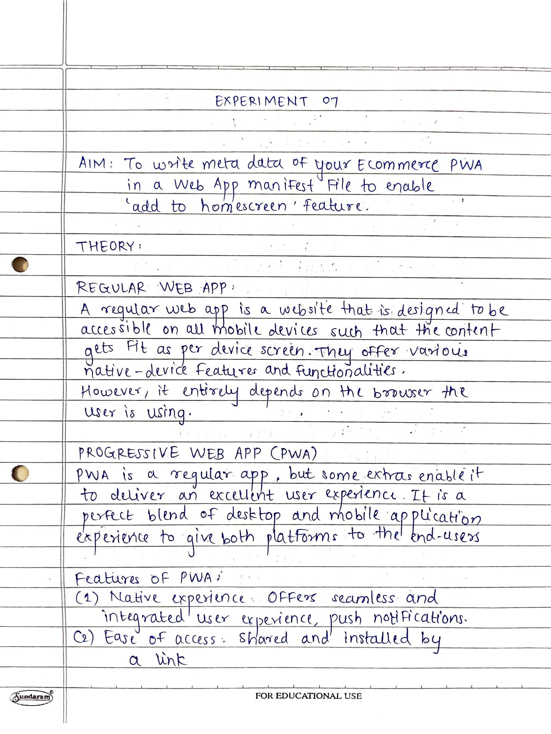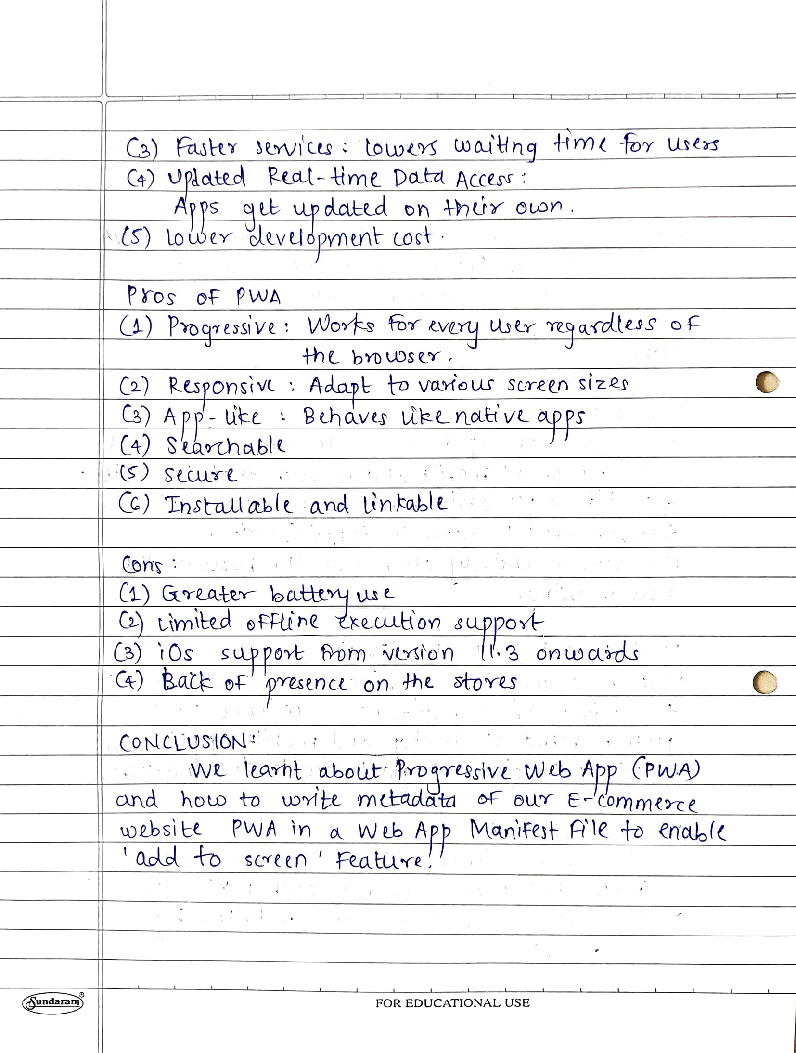

**CODE:**

**layout.html**

<head>

<title>Medi-OLX</title>

<meta charset="utf-8">

<meta name="viewport" content="width=device-width, initial-scale=1, shrink-to-fit=no">

<!-- Meta tags for PWA -->

<meta name= "apple-mobile-web-app-status-bar" content="#aa7700">

<meta name="theme-color" content="black">

<link rel="manifest" href="{{url_for('static', filename = 'manifest.json')}}">

</head>

<script>

window.addEventListener('load', () => {

registerSW();

});

// Register the Service Worker

async function registerSW() {

if ('serviceworker' in navigator) {

try {

await navigator

.serviceworker

.register('{{url_for('static', filename = 'js/serviceworker.js')}}');

}

catch (e) {

console.log('SW registration failed');

}

}

}

</script>

**manifest.json**

{

"name":"Medi-Olx",

"short_name":"Medi-Olx",

"start_url":"index.html",

"display":"standalone",

"background_color":"#5900b3",

"theme_color":"black",

"scope": ".",

"description":"This is a PWA tutorial.",

"icons":[

{

"src":"icons/gfg.png",

"sizes":"192x192",

"type":"image/png"

},

{

"src":"icons/gfg-logo.png",

"sizes":"512x512",

"type":"image/png"

}

]

}

**Serviceworker.js**

var staticCacheName = "pwa";

self.addEventListener("install", function (e) {

e.waitUntil(

caches.open(staticCacheName).then(function (cache) {

return cache.addAll(["/"]);

})

);

});

self.addEventListener("fetch", function (event) {

console.log(event.request.url);

event.respondWith(

caches.match(event.request).then(function (response) {

return response || fetch(event.request);

})

);});

**OUTPUT:**

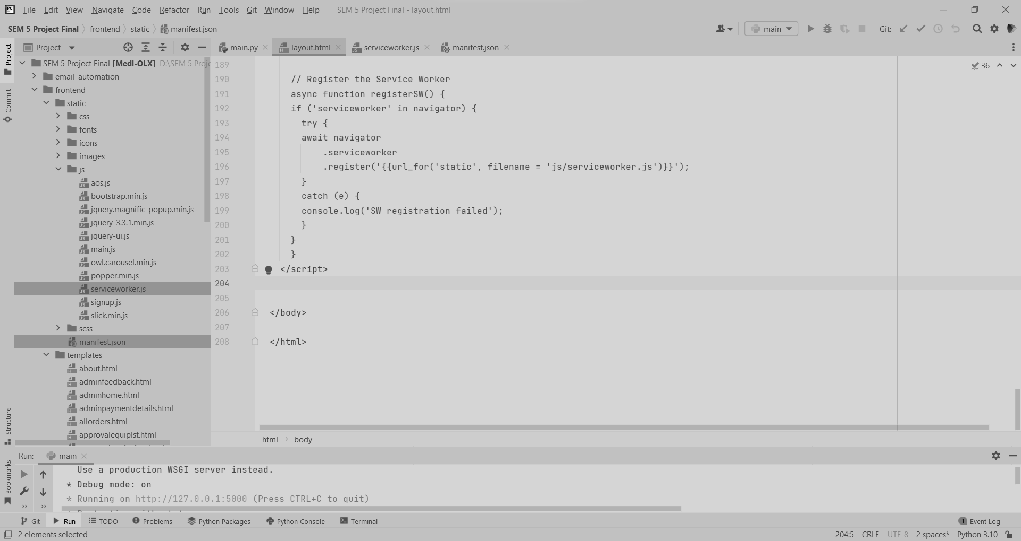

open Developer tools options

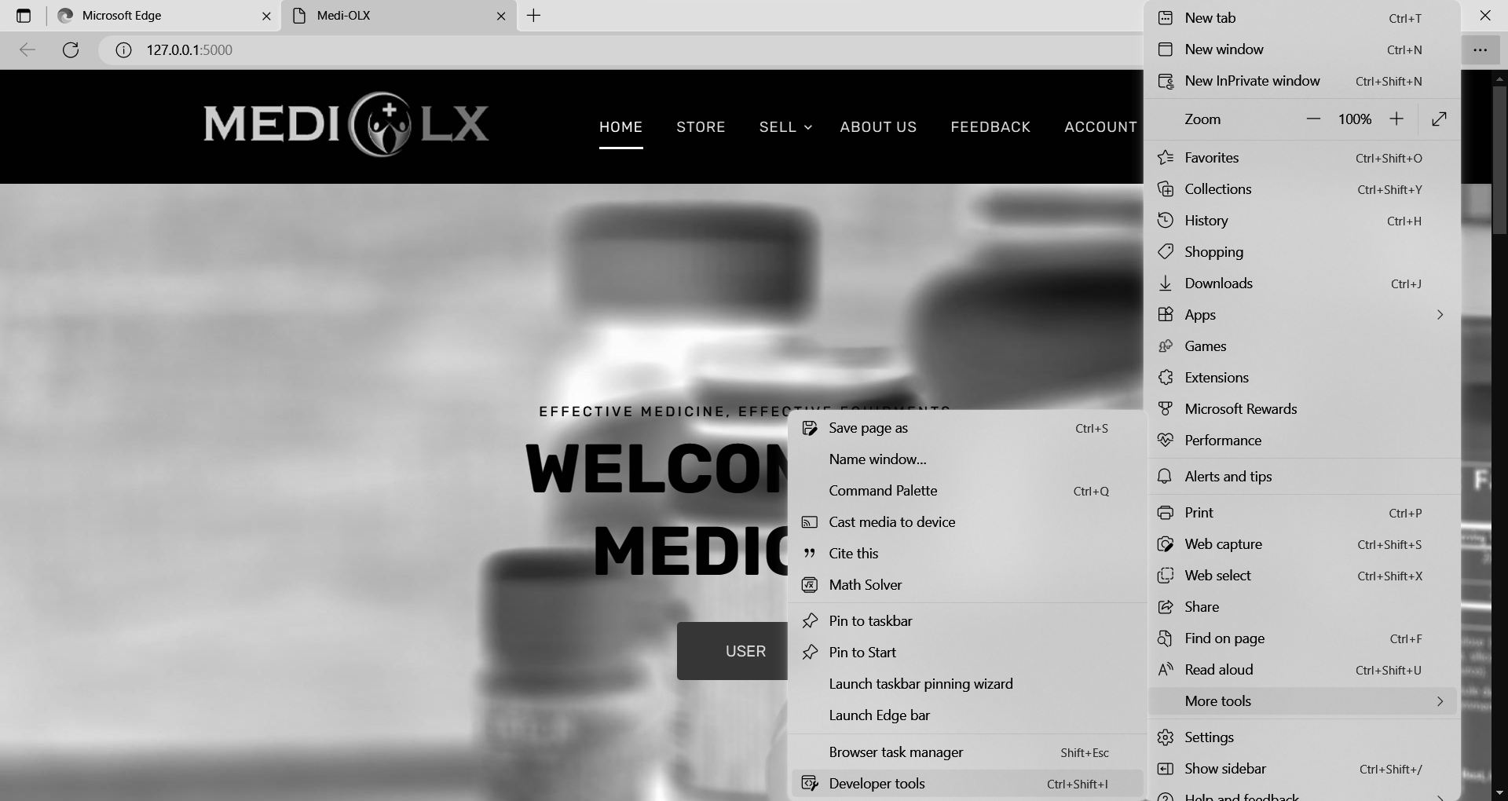

Applications

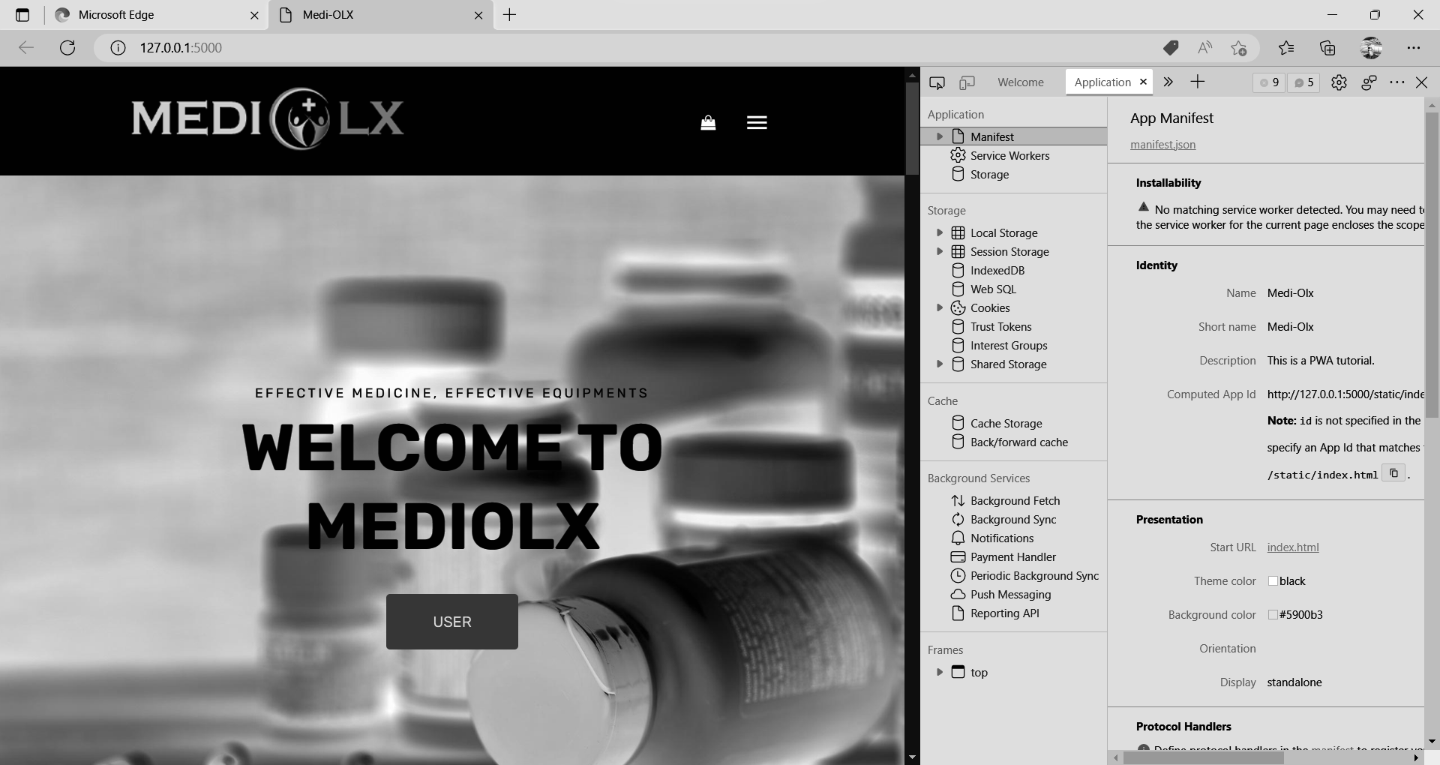

click on 3 dots on top right corner of browser from app option install this site as an app

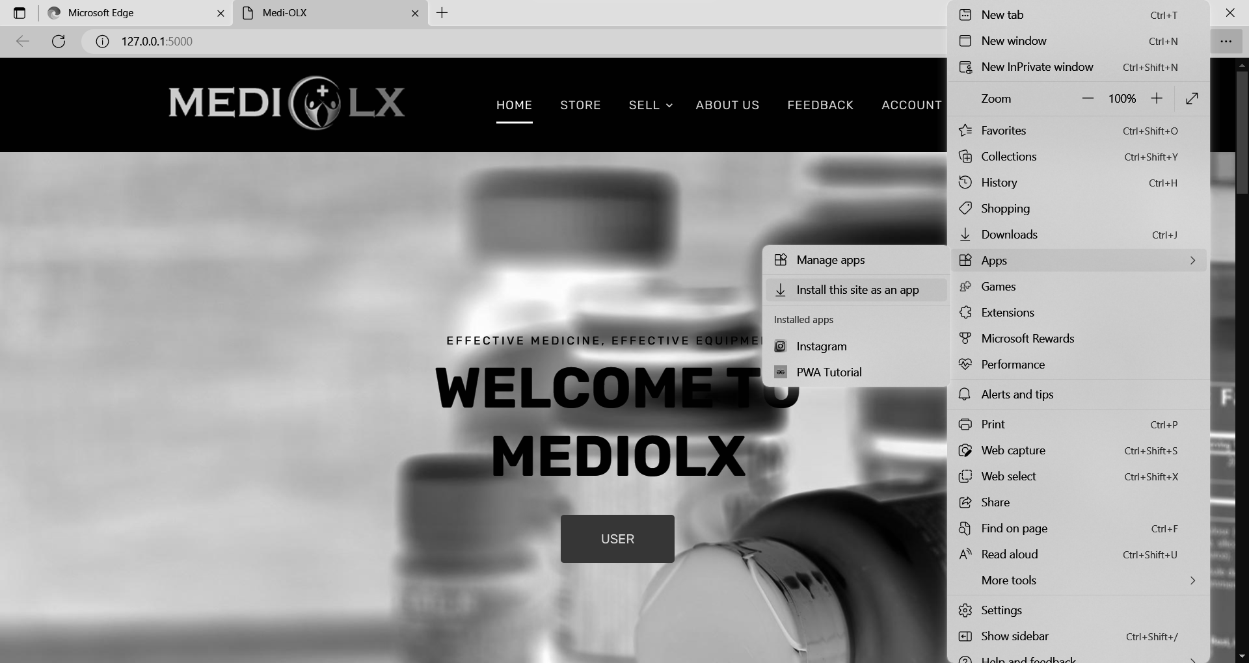

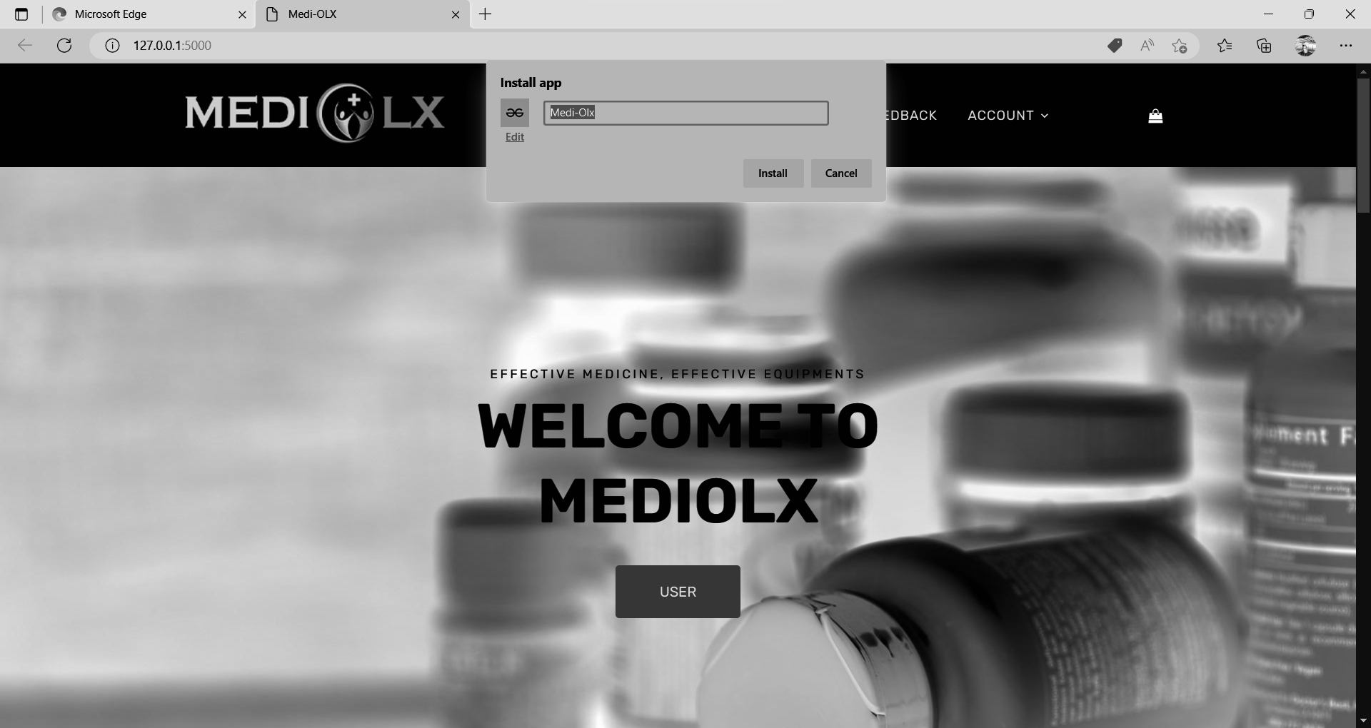

App icon will appear at the bottom

